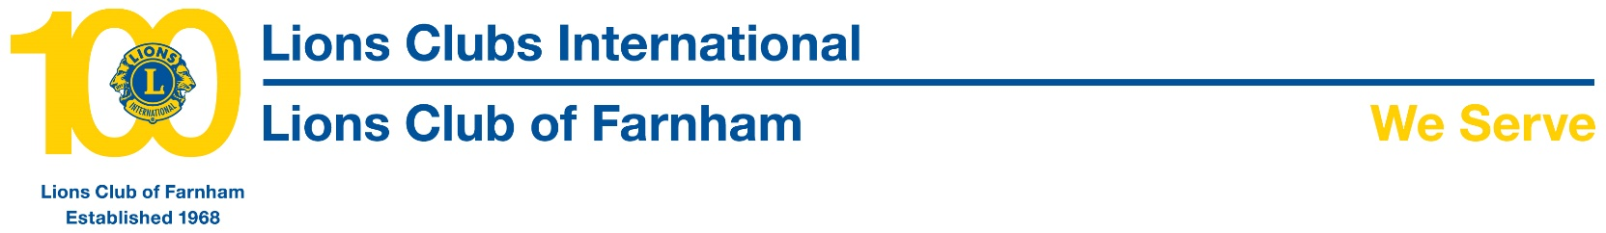

**2016 Xmas Parcel Collection**

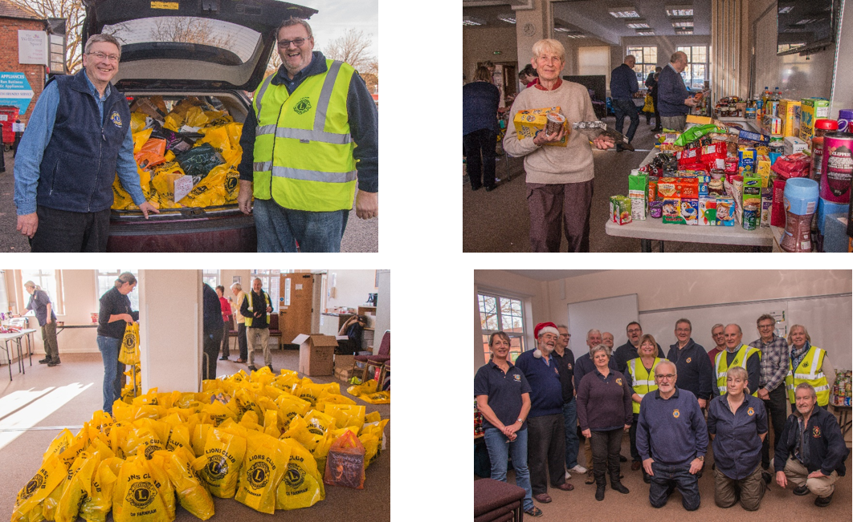

The Lions Club of Farnham have this year put together 200 Xmas Food Parcels which will, be distributed on their behalf by seventeen different agencies and hopefully bring a little cheer to the households that receive them.

A week or two ago over 1700 leaflets were dropped at households in the Farnham area along with a yellow bag by members of ‘Farnham Lions’ asking for food items to be donated to the annual appeal’. On Sunday morning those same households were revisited and many bags were collected and taken into Farnham for sorting.

The first task was to unpack all the bags, check date codes and then sort into various categories. The oldest item this year was 2009!

After that items are picked from each of the categories which included canned goods, desserts, savoury products, beverages, canned fish items and of course all the lovely Xmas treats. They are then re-bagged for singles, large family and very large family households before being taken to the ‘distributors’ who know who needs them most.

All that is left is to find a good home for the out of date stock and other unusable items and that happens too! Nothing is wasted.

Once again ‘Farnham Lions’ would like to say a big thank you to all who contributed and for being so generous.